CS691 – Computer Science, Spring 2022

Pace University



SYSTEM TEST PLAN

Food Pantry

Authors: Team 5

Date: 04/26/2022

**Table of content**

**INTRODUCTION:** **3**

**TESTING SCOPE:** **3**

**TESTING OBJECTIVE:** **3**

2.1 Features to be tested: 4

2.2 Features not to be tested: 4

**TEST PROCESS DEFINITION:** **4**

3.1 Test Process Phases 4

3.2 Test process phases and tasks: 5

**APPROACH TO SYSTEM TESTING:** **7**

4.1 Approach to Functional Testing 7

**ENTRY/EXIT CRITERIA** **7**

**ENVIRONMENTAL NEEDS:** **8**

**ROLES AND RESPONSIBILITIES** **9**

**TEST CYCLES AND SCHEDULE:** **9**

**RISKS AND CONTINGENCIES:** **10**

# **INTRODUCTION:**

This document covers the System Test Plan, which establishes a shared understanding of the scope, objectives, and strategy for system testing among the "Food Pantry" project stakeholders. The document also specifies the features to be tested, the testing entry/exit criteria, resource and responsibility allocation, and the testing timeline.

# **TESTING SCOPE:**

The testing scope includes two perspectives - the functional scope and technical scope.

The functional scope includes the following modules of the “Food Pantry” system: User Experience and Payment and User Registration/Login.

The technical scope includes the following architectural components:

● Web browser

● Web server

● Database server

# **TESTING OBJECTIVE:**

The primary focus of this System Test Plan is functional testing with the objective to evaluate the system implementation stability. The non-functional testing requires some special tooling to monitor performance characteristics, which is not available on this project.

The basis for developing functional tests and evaluating the system functionality includes the following sources:

* Business Requirements Document (BRD)
* User Stories (functional requirements)
* Requirements Composition Table (supplementary requirements)

## 2.1 Features to be tested:

* Register user: Whether a user would be able to register or not
* Account Authentication: Authenticating information provided by user and assigning user id
* Listing of food items to be donated: Whether a user would be able to list information, quantity etc.
* Providing and generating the information of the package: Whether information regarding the package would be generated accurately or not.
* Providing Time and location for the pick up of the donation : Testing whether a user would be able to provide a courier user with pick up time and location.

## 2.2 Features not to be tested:

* Handling User Profile
* Handling Donation Certificates
* Contacting user
* List dietary requirements
* List dietary restrictions
* Provide Drop-off time & location

# **TEST PROCESS DEFINITION:**

## 3.1 Test Process Phases

The test process for system testing can be defined as the following five phases:

* Test Planning
* Test Design
* Test Preparation
* Test Execution
* Test Reporting

The purpose of the **Test Planning** phase is to define the scope and objectives of testing, roles and responsibilities, and to define the testing approach.

The purpose of the **Test Design** phase is to determine the test design logic, to design test case specifications, and to determine requirements for test data.

In the **Test Preparation** phase, the objective is to set up a test environment, provision test data, and install the software under test in the QA environment.

The purpose of the **Test Execution** phase is to execute all test cases and to find and report software defects. The ultimate goal here is to evaluate the system stability by validating all features identified to be tested in the System Test Plan document.

The purpose of the **Test Reporting** phase is to provide stakeholders with visibility into the progress and completion of test execution. Testers will report defect metrics, produce test execution status reports, and evaluate the test exit criteria in the Test Completion Report. The approval of this report will be a basis for system testing sign off.

## 3.2 Test process phases and tasks:

The test process consists of five phases, which include test planning, design,

preparation, execution, and reporting. Each phase has a few tasks as defined

below:

| Process Phase | Tasks | Deliverables |
| --- | --- | --- |
| Test Planning | * Define scope and objectives of testing * Define roles and responsibilities * Define testing approach | * System Test Plan document |
| Test Design | * Identify test ideas, define an approach to designing test cases * Develop test case specifications * Measure test coverage * Determine requirements for test data | * Test Design specifications * Test Case specifications |
| Test Preparation | * Setup a test environment * Provision test data * Install the software in the test environment | * The system under test is up and running in the test environment * Test data available in the QA environment |
| Test Execution | * Execute all test cases * Find and report software defects * Evaluate the system stability * Validate all target features | * Software Defects * Test Execution Logs |
| Test Reporting | * Summarize and report the test execution results * Report defect metrics * Evaluate the test exit criteria * Create a test completion report, submit for stakeholder approval * Obtain stakeholder signoff on system testing | * Test Completion Report * Test Summary Report * Defect metrics |

# **APPROACH TO SYSTEM TESTING:**

## 4.1 Approach to Functional Testing

The overall approach to functional testing will be based on the black-box method:

* Test cases will be designed using some formal black-box techniques such as boundary-value analysis, equivalent-class partitioning, cause-effect graphing, decision tables, and state-transition testing, where applicable.
* Test execution will be conducted manually, from the user perspective and based on formal test case specifications.

The test execution results will be captured and reported in test execution logs.

# **ENTRY/EXIT CRITERIA**

This section defines both Entry and Exit Criteria for test execution and is intended to establish a common understanding about the conditions when the test execution can start and when it can stop.

Entry Criteria

The test Entry Criteria include the following items:

▪ The application build is produced and deployed to the test environment.

▪ The system test plan is produced and approved.

▪ The test environment is ready for testing.

▪ Test Designs and test case specifications are completed.

Exit Criteria

The test Exit Criteria include the following items:

▪ All test cases have been executed and passed.

▪ Zero defects of Critical and High-severity remain open.

▪ Open defects of Medium and Low severity have known workarounds.

▪ Test Summary report is produced and published.

# **ENVIRONMENTAL NEEDS:**

The Test Environment should be available to start test execution. It includes an internet enabled device with a web browser  to access the web server and database server. The architecture of the test environment is shown below.

**Application: FoodPantry**

**Type: Application Architecture**

**View: Process View**

**Style: Client-Server Pattern**

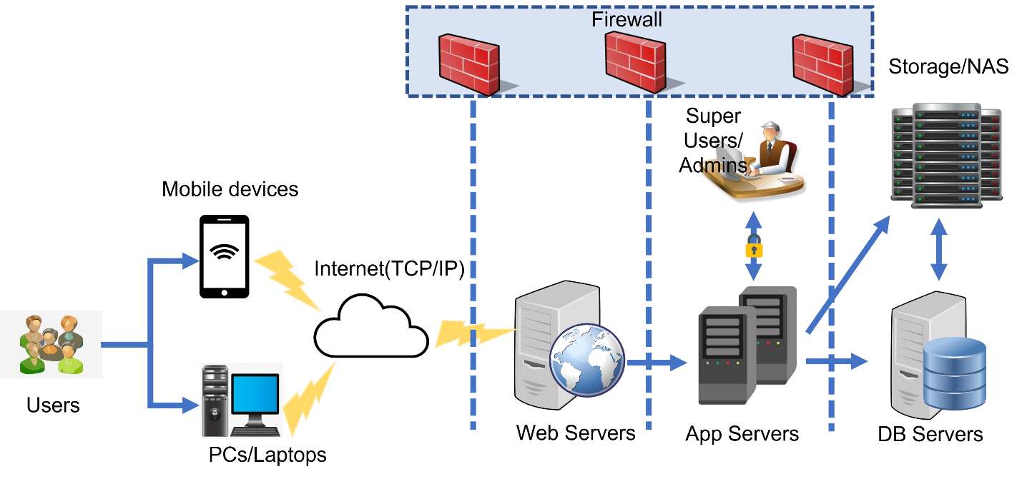

# **ROLES AND RESPONSIBILITIES**

The project team has six members that are assigned various project roles

including Project Manager, Product Owner, Lead Business Analyst, Lead

Developer, DBA, Lead QA Analyst.

| PROJECT ROLE | RESPONSIBILITY |
| --- | --- |
| Project Manager | Reviewing and approving the System Test Plan, test design specifications.  Managing the test environment preparation.  Tracking the testing schedule and results. |
| Lead QA Analyst | Designing a test plan, establishing a test repository, developing test case specs, executing testing and reporting defects. |
| Product Owner | Contributing to the test plan and test case specifications.  Reviewing test results. |
| Lead Business Analyst | Contributing to the test plan and test case specification.  Reviewing test results. |
| Lead developer | Establishing and maintaining the test environment, assisting a Lead QA analyst throughout the testing process. |
| DBA | Assisting the lead developer in establishing and maintaining the test environment. |

# **TEST CYCLES AND SCHEDULE:**

The system test execution will be conducted as 5 test cycles that are aligned

with 5 application modules as follows:

* **Cycle 1: Register user**

This cycle will focus on Testing the first part, i.e. registering the user module.

* **Cycle 2: Account authentication**

This cycle will focus on Testing, authenticating the registered user in the first cycle.

* **Cycle 3: List Food items for donation**

This cycle will focus on Testing input of enlistment of food items by the donor.

* **Cycle 4: Provide package information**

This cycle will focus on Testing inputting the information of the package such as donor, contents, time etc.

* **Cycle 5: Provide Pickup time & location**

This cycle will focus on Testing providing pick up time and location by user.

# **RISKS AND CONTINGENCIES:**

This section highlights a few potential risks and contingencies that maybe happened during the system testing.

* The testing process might be hampered by a lack of collaboration among team members which can be easily tackled with communication and appropriate distribution of workload.
* A lack of testing resources can result in more time needed to complete test case specifications
* Given the lack of testing resources, there may be a delay.
* Too many defects require a longer time to fix defects and complete testing.
* Changes to the implementation scope or existing functional requirements can impact the test execution schedule
* Instability of the test environment can impact the test execution schedule.